Page 6 Device for Programming

When the player presses the side button, all 5 leds will turn on. In the app, the area is turned on as shown (cyan like color).
The user may move the led group to the left or right side, depending if there is anything obstructing it. If there is already an led in the way to the side it wants to move, it cannot move any further.

Likewise, the area needs to reflect the current position the 5 leds moved to.

If the user moved a complete 5 leds over, then it simply acts as a new location. For example, player picked PLAYER 0. Moved to counter-clockwise 5 times. Now the system recognizes it as Player 1 and ignores PLAYER 0.

Only the Cyan moves in the graphics and moves under the dividers but over the black and under the shine reflection.


To move perfectly, you need to figure out where the leds are. So you might need trial and error to determine what angle to use for each move and how to program the positions.

Page 9 Device for Programming

Similar to Page 6 Device, but it has a different graphic. The location where the group leds are must reflect the same location as the green on the graphics for that player.

In the center of this device will contain the current card in the discard pile.

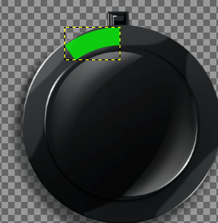
This device also contains a chaser that will revolve along the edge of the device using the chaser animation.

